Guidelines for Employees to Fill ESIC Form 1
(Employee Declaration Form for ESIC Enrollment)
Employees are required to complete ESIC Form 1 accurately to avoid delays in ESIC enrollment.
Please read the below instructions carefully before filling in the form.
1. Before You Start
Please keep the following information ready before filling in ESIC Form 1:
- Name exactly as per your ID/Aadhaar
- Date of birth
- Present and permanent address with PIN code
- Mobile number and email ID
- Marital status
- Previous ESIC Insurance Number, if applicable
- Dependent family member details
Documents Required
Please keep the following two files ready in .jpeg format, with each file size between 50 KB and 80 KB:
- Your PAN card copy
- Your individual passport-size photograph
- Family member's Individual passport-size photographs

The above 3 files must be shared as separate files along with:
- Form 1 PDF copy
- Excel file
2. Important Instructions Before Filling the Form
- Refer to the sample ESIC Form shared with you while filling in your ESIC Form 1.
- Fill only the fields highlighted in yellow.
- Leave all other fields blank.
3. Form Filling Guidelines
Part A: Insured Person Details
Insurance Number
- Leave this field blank.
- After your enrollment is completed, the employer will update your latest ESIC Insurance Number in this section.
Personal Details
Please fill in all details exactly as per your official records:
- Name (in BLOCK LETTERS): Enter your name as per Aadhaar.
- Father’s/Husband’s Name: Mention the full name as per your(employee) Aadhaar, as applicable.
- Date of Birth: Use the format DD/MM/YYYY.
- Marital Status and Gender: Tick or mark the correct option.
- Present Address: Mention your current residential address, as this is used for mapping ESIC services.
- Permanent Address: If the same as the present address, mention the same.
- Email ID: Provide an active and reachable email ID to avoid delays.
- Dispensary:
  - Please identify your nearest ESIC dispensary and enter the name and full address in the relevant section of the form.
  - To find the correct dispensary, visit the ESIC website (https://esic.gov.in/) and use the Quick Finder option.
  - Under Quick Finder, select “Dispensary”, choose your State, and click Search as shown in the below image.
  - For faster results, use Ctrl+F and search using your PIN code or you can manually search by scrolling the window.
  - After identifying the nearest dispensary, fill in the dispensary name and address accurately in the form.
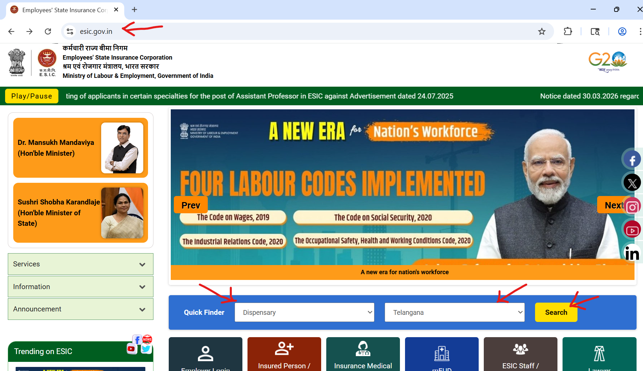

Part B: Previous Employment Details
(Only if applicable)
- If you were previously covered under ESIC, provide your earlier employer details.
- This helps link your previous ESIC Insurance Number correctly and ensures continuity of benefits.
- Mention the following:
  - Previous ESIC Insurance Number
  - Previous establishment employer code
  - Name of the establishment
  - Address of the establishment
Important:
- Please check your previous employer’s payslips to identify your ESIC number.
- If required, please take assistance of your previous employers to know your previous ESIC number and previous employer code
- If you already have a previous ESIC number, it is mandatory to mention it.
- If the previous ESIC number is not provided, ESIC portal validation may fail, and your enrollment may be delayed.
Part C: Nominee Details
- Provide the following details of your nominee:
  - Nominee name
  - Relationship
  - Address
This information is required for cash benefit payment in case of death.
Part D: Family Particulars
(For dependent medical benefits)
- List all eligible dependent family members, such as spouse, children, and dependent parents, as applicable under the scheme.
- For each family member, provide:
  - Name
  - Date of birth in DD/MM/YYYY format
  - Relationship
  - Whether they reside with you
  - If not residing with you, mention their town and state
4. Employer Particulars
The following fields are generally filled in or verified by HR:
- Employer’s Code Number
- Employer name and address
- Date of appointment
Employees should leave these fields for employer.
5. Declaration, Signature, and Verification
- Read the declaration carefully before signing.
- Sign or provide thumb impression only after verifying that all entries are correct.
- The employer will complete the verification and sign with seal, as required.
6. Common Errors to Avoid
To avoid delays in ESIC enrollment, please ensure the following:
- No mismatch in name or date of birth with Aadhaar or official records
- Previous ESIC number is not missed, if applicable
- Photograph is attached
- Address and PIN code are complete
- Nominee details are filled correctly
- Family members’ dates of birth are not skipped

